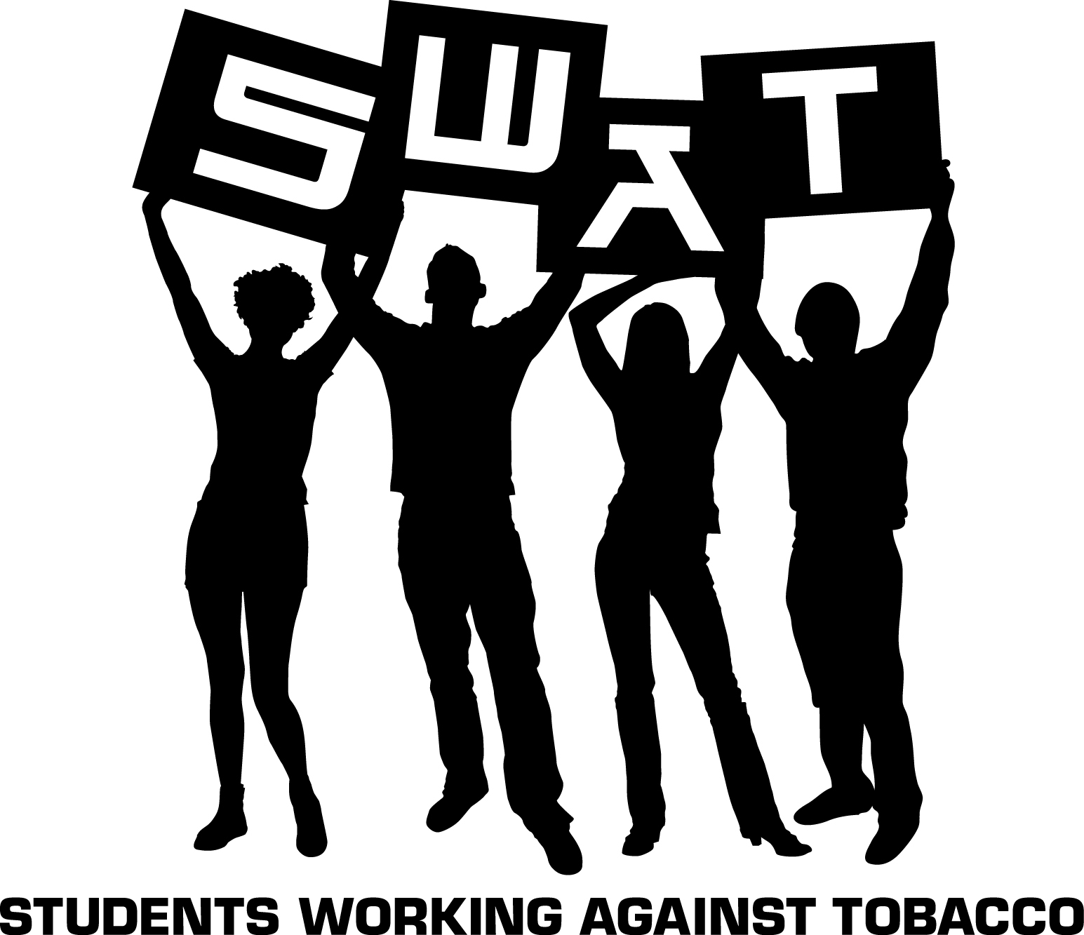
FOR IMMEDIATE RELEASE
October 24, 2014

Sarasota County Teen Helps Lead the Statewide Movement Against Tobacco
Students Working Against Tobacco Elect Evianna Gianoplus to Its Leadership Board

Sarasota County — Students Working Against Tobacco (SWAT), the statewide youth-led movement, announced the names of its new Youth Advocacy Board members. Evianna Gianoplus of Pine View School was named Youth Advocacy Board (YAB) Member. YAB members are elected by their peers to keep SWAT moving in the right direction.

The Youth Advocacy Board works in collaboration with the Florida Department of Health’s Bureau of Tobacco Free Florida to help plan the direction and goals of the SWAT organization and of the youth prevention component of the state’s tobacco control campaign. Students work with county grantees on a local level to support initiatives that educate others about tobacco use, help protect youth from tobacco, and strengthen local policies, especially those that protect the public from secondhand smoke.

“I’m looking forward to being on the YAB because I have always wanted to become more involved with SWAT and this is the perfect opportunity,” said Evianna Gianoplus. “I am a hard worker and have many creative ideas that will benefit the board. I am really excited for this year on the YAB and working with the other YAB members. "

SWAT aims to empower, educate and equip Florida youth to revolt against Big Tobacco. SWAT is a movement of empowered youth working together to de-glamorize tobacco use. Their efforts aim to shape tobacco-free norms, make tobacco less desirable, less acceptable and less accessible. ‘

“Youth advocates are the next generation of leaders in Florida and across the country,” said Tobacco Free Florida Bureau Chief Shannon Hughes. “These enthusiastic students work diligently with a passion to create positive change and raise awareness amongst their peers and community about the dangers of tobacco use.”

Members of the SWAT Youth Advocacy Board will serve a term through June 30, 2015.

ABOUT TOBACCO FREE FLORIDA
Tobacco Free Florida is a statewide cessation and prevention campaign funded by Florida's tobacco settlement fund. Tobacco Free Florida is managed by the Florida Department of Health, specifically the Bureau of Tobacco Free Florida.

Smokers and smokeless tobacco users interested in quitting are encouraged to use one of the 3 Free & Easy Ways to Quit. To learn about Tobacco Free Florida and the state's free cessation resources, visit www.tobaccofreeflorida.com or follow the campaign on Facebook at www.facebook.com/TobaccoFreeFlorida or Twitter at www.twitter.com/tobaccofreefla.

The Department works in collaboration with its statewide network of county health departments to protect, promote and improve the health of all people in Florida through integrated state, county and community efforts. During 2014, the Department is recognizing 125 years of public health in Florida with educational opportunities and events. Please visit www.FLHealth125.gov for more information.
----------------------------------------------------------------------
MEDIA NOTES:

DOH-Sarasota Media Contact: Dianne Shipley, 941-861-2852; cell 941-302-1058; DOHSarasotaNews@flhealth.gov
Website: www.sarasotahealth.org

